Published by Rolling Thunder® Inc. Chapter 1 Ohio November, 2021
The Thunder Gazette

PLEASE NOTE

OUR NEXT MEMBERSHIP

MEETING WILL BE HELD AT

V.F.W. POST #6768
8584 Olde Eight Rd.
Northfield, OH

SUNDAY, November 21, 2021
2:00 p.m.

We will meet at the funeral home and attend the 1:00 service (see details on this page). Then we will go back to the Post for our meeting. Please wear white shirt, black pants and your vests.

Our veterans need white socks. We will be collecting white socks at each meeting.

***************

To be a member in good standing, one must:
a. Attend at least 3 meetings & 3 events per year;
b. Pay the annual membership dues of $30/yr;
c. Abide by the Membership Patch rules;
d. Remain loyal to Rolling Thunder® in word, deed and
action;
e. Conduct him/herself in a professional and courteous
manner at all times.

UPCOMING EVENTS

Sunday, November 21, 2021 – Board/ Membership Meeting – 2:00 p.m. (short Board meeting after the membership meeting)

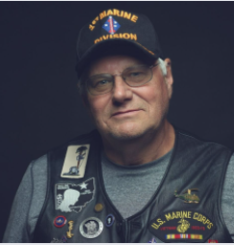

Sadly, we lost Hank Langowski on November 12, 2021. Hank was an active member of Rolling Thunder, Chapter 1 Ohio and currently served on the Board of Directors. Hank proudly served his country in the Marines during the Vietnam War.
Memorial Contributions may be made in Hank’s name to the Northfield V.F.W. Post 6768, 8584 Olde 8 Rd, Northfield, Ohio 44067. A memorial service will be held at 1 PM Sunday, November 21, 2021 at Johnson-Romito Funeral Home, 99 W. Aurora Rd., Northfield, OH 44067 where friends will be received following the service until 4 PM. All are asked to meet at Ohio Western Reserve National Cemetery, 10175 Rawiga Rd, Seville, OH 44273 at 9:45 AM on Monday, November 22, 2021 for a committal service with military honors for Hank. Please arrive at the cemetery 15 minutes prior to the start of the service. Masks will be required at the cemetery.

Rest easy, Hank. We will miss you!

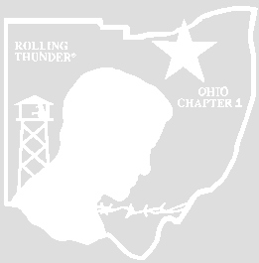
CHAPTER OFFICERS, BOARD MEMBERS
AND PLATOON LEADERS

PRESIDENT

VICE-PRES LEW BALLARD 440-725-8157

SECRETARY CHERYL PILNY 440-543-8468

TREASURER ANDY KLUSH 330-620-6047

CHAIRMAN OF THE BOARD
CHUCK KETTLER 216-401-4984

BOARD MEMBERS
BILL STREET
JEFF BRADY 440-669-1794

PAUL WIGET 440-476-3656
DAN HUBBARD 216-741-3992
(ALTERNATE) MIKE NEILAN 440-241-2655

CHAPLAIN DAN MCGINNIS 330-618-1720

RUN COORDINATOR OPEN

MEMBERSHIP SUSAN BAILEY 440-639-2222

QUARTERMASTER
DAN HUBBARD 216-741-3992

ASST. QUARTERMASTER

SARGENT AT ARMS

NEWSLETTER STAFF
CHERYL PILNY 440-543-8468

PLATOON LEADERS:
#1 MIKE NEILAN 440-241-2655

#2 TOM BLECHSCHMID 440-349-2470

#3 SALLY FELEAN 440-439-4914

#4 SUSAN BAILEY 440-639-2222

STATE LIAISON
WE CARE YVONNE GIERMAN 440-285-3864
arphersfolks@windstream.net

GOVERNMENT AFFAIRS
CHUCK KETTLER 216-401-4984

WADE PARK VISITS –
WINSTON/SUE BAILEY 440-639-2222

EVENTS CHAIR JEFF BRADY 440-669-1794

PUBLIC RELATIONS CHUCK KETTLER 216-401-4984

EDUCATION CHAIR DAN MCGINNIS 330-618-1720

Address: Rolling Thunder Chapter 1 Ohio
P. O. Box 1145
Mentor, OH 44060

Web Site Address: www.rollingthunder1ohio.org
Webmaster: CHIP KETTLER 330-472-0871
Please send any pictures you may have to Chip at ckettler6480@yahoo.com

Check us out on Facebook: Rolling Thunder Chapter1 Ohio
***************

MISSION STATEMENT

THE MAJOR FUNCTION OF ROLLING THUNDER® INC. IS TO PUBLICIZE THE POW-MIA ISSUE: TO EDUCATE THE PUBLIC THAT MANY AMERICAN PRISONERS OF WAR WERE LEFT BEHIND AFTER ALL PREVIOUS WARS, AND TO HELP CORRECT THE PAST AND TO PROTECT FUTURE VETERANS FROM BEING LEFT BEHIND SHOULD THEY BECOME PRISONERS OF WAR-MISSING IN ACTION. WE ARE ALSO COMMITTED TO HELPING AMERICAN VETERANS FROM ALL WARS.

Rolling Thunder®, Inc. is a non –profit organization and everyone donates his or her time because they believe in the POW-MIA issue.
***************

Our Adopted MIA/POW – Gregory Harris

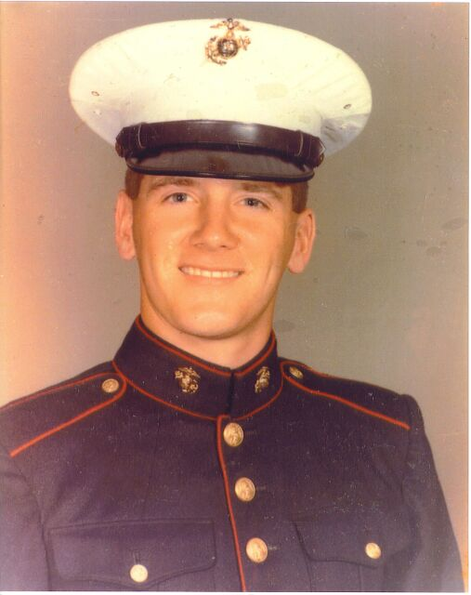

Government Affairs – Berney Jarosz

A member from NJ Chapter 4 contacted me after speaking with District Director Christopher Chin from Representative Jeff VanDrew’s office. Actually, he spoke to Joe Bean who sent Matt (Chico) to get me at the Staten Island event. He let me know about, some of the legislation that Mr. Van Drew was working on. These are some of the bills That Mr. Van Drew is working on that we are supporting: ¬

HR 1476 - PFC Joseph P. Dwyer Peer Support Program Act - This bill requires the Department of Veterans Affairs (VA) to establish the PFC Joseph P. Dwyer Peer Support Program to make grants to eligible entities for peer-to-peer mental health programs for veterans. ¬

HR 1656 - TREAT PTSD Act - This bill requires the Department of Veterans Affairs (VA) and the Department of Defense (DOD) to furnish stellate ganglion block to certain veterans or members of the Armed Forces (including reserve components) diagnosed with post-traumatic stress disorder (PTSD). Blocking the stellate ganglion (a group of nerves at the base of the neck) by injecting a local anesthetic is a treatment that may alleviate PTSD symptoms. ¬

HR 1022 - PAWS Act of 2021 - This bill requires the Department of Veterans Affairs (VA) to implement a grant program for the purpose of pairing service dogs with eligible veterans. Organizations that receive grants must provide veterinary health insurance coverage, hardware, and travel expenses for each service dog and veteran participating in the program. ¬

HR 1448 - Puppies Assisting Wounded Servicemembers for Veterans Therapy Act - This bill implements a program and a policy related to service dog therapy for veterans. Specifically, the bill requires the Department of Veterans Affairs (VA) to implement a five-year pilot program to provide canine training to eligible veterans diagnosed with post-traumatic stress disorder as an element of a complementary and integrative health program. Eligible veterans are those who are enrolled in the VA health care system and have been recommended for participation by a qualified mental health care provider or clinical team. ¬

HR 1123 - Veteran Suicide Prevention Act - This bill requires the Department of Veterans Affairs (VA) to complete a review of the deaths of all covered veterans who died by suicide during the five-year period preceding the enactment of this bill. Covered veterans are those who received VA hospital care or medical services during the five-year period preceding the death of the veteran. I have sent a letter of support to Congressman Van Drew. I also sent a letter of support to the Secretary of Veterans Affairs, the Honorable Denis R. McDonough to thank him for pushing through the presumptive Disability Benefits Status covering asthma, rhinitis, and sinusitis. Adding that hopefully they can work to get the other presumptive disabilities added.

117th Congress Veteran Bills Being Supported by Rolling Thunder®, Inc. -

1) S.657 - A bill to modify the presumption of service connection for veterans who were exposed to herbicide agents while serving in the Armed Forces in Thailand during the Vietnam era, and for other purposes. (04/28/2021 Referred to the Committee on Veterans' Affairs. Hearings held.) No News

2) HR 333 - The Disabled Veteran's tax termination act. es. (03/08/2021 Referred to the Subcommittee on Disability Assistance and Memorial Affairs.) No News

3) H.R.2281 - To award a Congressional Gold Medal to the United States Army Dust Off crews of the Vietnam War, collectively, in recognition of their extraordinary heroism and life-saving actions in Vietnam. (03/29/2021) Referred to the Committee on Financial Services, and, in addition to the Committee on House Administration, for a period to be subsequently determined by the Speaker, in each case for consideration of such provisions as fall within the jurisdiction of the committee concerned). No News

4) S.1198 - A bill to amend title 38, United States Code, to improve and expand the Solid Start program of the Department of Veterans Affairs, and for other purposes. (06/23/2021 Committee on Veterans' Affairs. Hearings held) No News

5) S 89 and HR 746 Ensuring Survivor Benefits during Covid-19 Act of 2021. (06/24/2021 S 89 Placed on Senate Legislative Calendar under General Orders. Calendar No. 83.) No News (HR 746 03/16/2021 Referred to the Subcommittee on Disability Assistance and Memorial Affairs) No News

REMEMBER: The NATIONAL SUICIDE
HOTLINE DESIGNATION ACT OF 2020 was passed on October 17,2020. The number 9-8-8 is the universal number for the national suicide prevention and mental health crisis hotline.

More information may be found on the Rolling Thunder, Inc. National’s website under the heading “Government Affairs” www.rollingthunder1.com

“UNTIL THEY ALL COME HOME”

Remember: You are the voice of our POW and MIAs.

District | Name | Office Room | Phone
1st | Chabot, Steve | 2408 Rayburn House Office Building  Washington, DC 20515 | (202) 225-2216
2nd | Wenstrup, Brad | 2419 Rayburn House Office Building  Washington, DC 20515 | (202) 225-3164
3rd | Beatty, Joyce | 2303 Rayburn House Office Building  Washington, DC 20515 | (202) 225-4324
4th | Jordan, Jim | 2056 Rayburn House Office Building  Washington, DC 20515 | (202) 225-2676
5th | Latta, Robert E. | 2467 Rayburn House Office Building  Washington, DC 20515 | (202) 225-6405
6th | Johnson, Bill | 2336 Rayburn House Office Building  Washington, DC 20515 | (202) 225-5705
7th | Gibbs, Bob | 2217 Rayburn House Office Building  Washington, DC 20515 | (202) 225-6265
8th | Davidson, Warren | 2113 Rayburn House Office Building  Washington, DC 20515 | (202) 225-6205
9th | Kaptur, Marcy | 2186 Rayburn House Office Building  Washington, DC 20515 | (202) 225-4146
10th | Turner, Michael | 2082 Rayburn House Office Building  Washington, DC 20515 | (202) 225-6465
11th | Fudge, Marcia L. - Vacancy | 2344 Rayburn House Office Building  Washington, DC 20515 | (202) 225-7032
12th | Balderson, Troy | 2429 Rayburn House Office Building  Washington, DC 20515 | (202) 225-5355
13th | Ryan, Tim | 1126 Longworth House Office Building  Washington, DC 20515 | (202) 225-5261
14th | Joyce, David | 2065 Rayburn House Office Building  Washington, DC 20515 | (202) 225-5731
15th | Stivers, Steve | 2234 Rayburn House Office Building  Washington, DC 20515 | (202) 225-2015
16th | Gonzalez, Anthony | 2458 Rayburn House Office Building  Washington, DC 20515 | (202) 225-3876

***************
Remains Identified

WWII Remains Identified:
U.S. Army Air Forces 1st Lt. John J. Heffeman, Jr.
U.S. Army Pvt. Edward M. Ryan
USMC Pfc. Walter L. Collier
U.S. Navy Fireman 2nd Class Edward E. Casinger
U.S. Navy Fireman 1st Class Hal J. Allison
U.S. Navy Seaman 2nd Class Pete Turk
U.S. Navy Seaman 2nd Class Joseph M. Robertson
U.S. Army Pvt. Robert J. Herynk
U.S. Army Air Forces Staff Sgt. Richard D. Salsbury
U.S. Navy Seaman 2nd Class Laverne A. Nigg
U.S. Navy Fireman 1st Class James O. McDonald
U.S. Army Staff Sgt. William R. Linder
U.S. Army Pvt. Archie V. Fleeman
U.S. Navy Fireman 2nd Class Benjamin C. Terhune
U.S. navy Seaman 1st Class Buford H. Dyer

Korean War Remains Identified:
U.S. Army Pfc. Jimmy Rowland
U.S. Army Pfc. Jack E. Lilley
U.S. Army Sgt. Howard R. Belden
U.S. Army Cpl. Marvin D. Actkinson
U.S. Army Pfc. Don D. Dowler, Jr.
***************
Photos from a recovery operation in Xiangkhouang Province, Lao Peoples Democratic Republic earlier this month. There are currently 289 missing service members from the Vietnam War believed to be located in Laos. DPAA’s mission is to achieve the fullest possible accounting for missing and unaccounted-for U.S. personnel to their families and our nation.

Makes you realize the hard work that is put into the search. God Bless these workers. Bring our boys home!



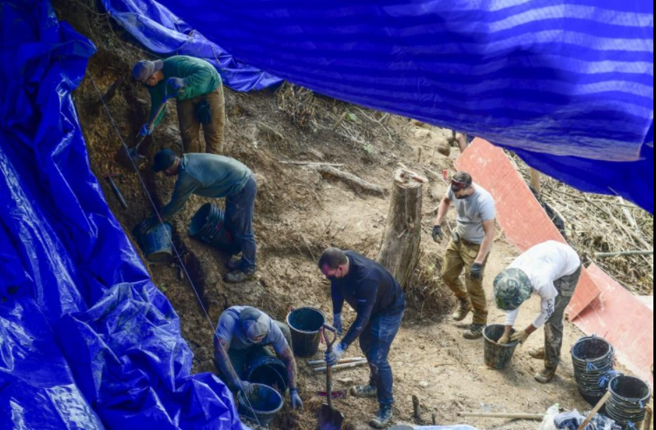

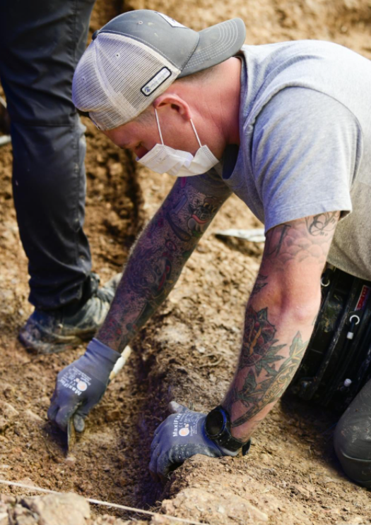
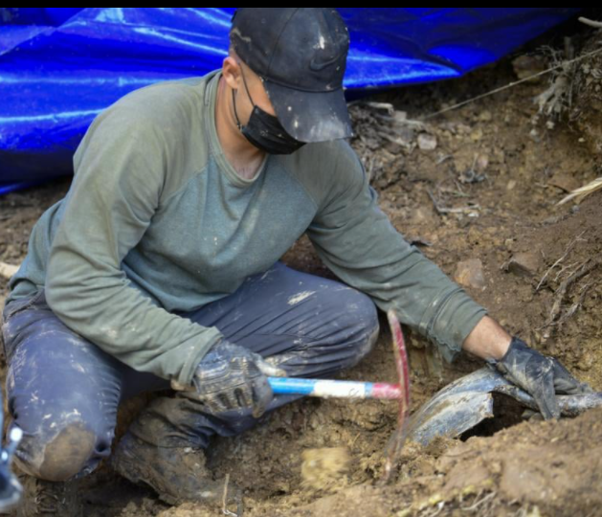

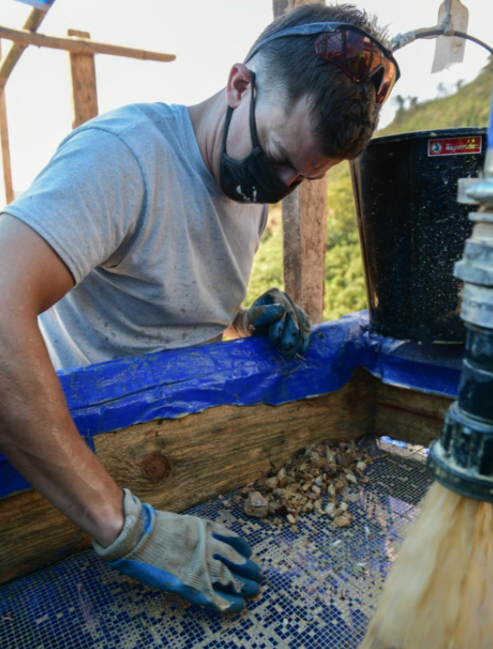

***************
I was prepared to fight, prepared to die. But I was not prepared for my country to leave me behind.
***************

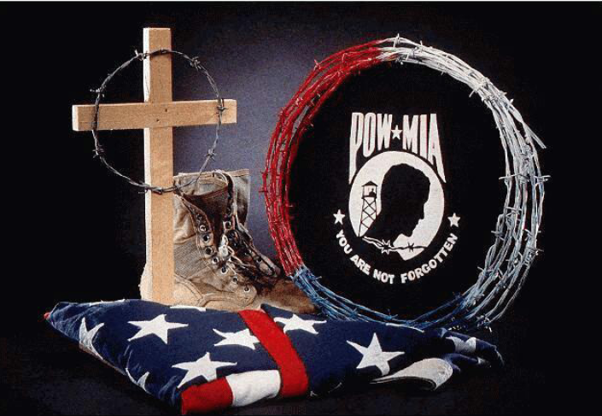

Chaplain’s Corner
(submitted by Dan McGinnis)

Hear my prayer, O Lord, give ear to my supplications: in thy faithfulness, answer me, and in they righteousness.
(Psalms 143:1)

Inspiration:

Be under no illusions, life can be tough even for Christ’s most devoted followers. One way we may seek comfort is in prayer—for our loved ones who may be sick or hurting, for those around the world perhaps under tyranny or amidst the fog of war. God is not some simple umbrella to be opened in times of need only, but He is as our closest friend who wishes to hear our thoughts and inner feelings. It is okay to be angry sometimes, to be desparate. But do not be dismayed if God doesn’t give you what you always want—for He has a plan for us, even if often we don’t see the path of His righteousness.

Prayer:

Heavenly Lord God, I thank you in the name of Your son, Jesus Christ and the Holy Ghost. I thank you for Your mercy and pray for Your continued grace; to me, my friends, family, and even my enemies. I need Your help and guidance every day, and wish for You to teach me to trust in You Lord, and I move forward into Your grace within each and every prayer that passes my lips. Amen.

***************

What is a Vet?

Some veterans bear visible signs of their service: a missing limb, a jagged scar, a look in the eye. Others may carry the evidence inside them: a pin holding a bone together, a piece of shrapnel in the leg or, perhaps, another sort of inner steel: the soul’s ally forged in the refinery of adversity. Except in parades, however, the men and women who have kept America safe wear no badge or emblem. You can’t tell a vet just by looking.

He is the cop who spent six months in Saudi Arabia sweating two gallons a day making sure the armored personnel carriers didn’t run out of fuel.

He is the barroom loudmouth, whose overgrown frat-boy behavior is outweighed by four hours of exquisite bravery near the 38th parallel.

She or he is the nurse who went to sleep sobbing every night for two solid years in Da Nang.

He is the P.O.W. who went away one person and came back another—if he came back at all.

He is the Quantico drill instructor who has never seen combat, but has saved countless lives by turning rednecks and gang members into soldiers and teaching them to watch each other’s backs.

He is the parade-riding Legionnaire who pins on his ribbons and medals with a prosthetic hand.

He is the career quartermaster who watches the ribbons and medals pass him by.

He is the old guy bagging groceries at the supermarket—palsied and aggravatingly slow—who helped liberate a Nazi death camp, and who wishes all day long that his wife were still alive to hold him when the nightmares come.

He is an ordinary and yet extraordinary human being—a person who offered some of his life’s most vital years in the service of his country, and who sacrificed his ambitions so others would not have to sacrifice theirs.

He is a soldier and a savior and a sword against the darkness, and he is nothing more than the finest, greatest testimony on behalf of the finest, greatest nation ever known.

So remember, each time you see someone who has served our country, just lean over and say “Thank You”. That’s all most of these people need and, in most cases, it will mean more than any medals they could have been awarded. Two little words that mean a lot: “THANK YOU!”

***************



